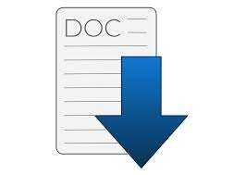

**Author Team 4 :**

Abdelrahman Mohamed Gomaa

Abdelrahman Mohamed Ahmed

Islam Abu elsoud

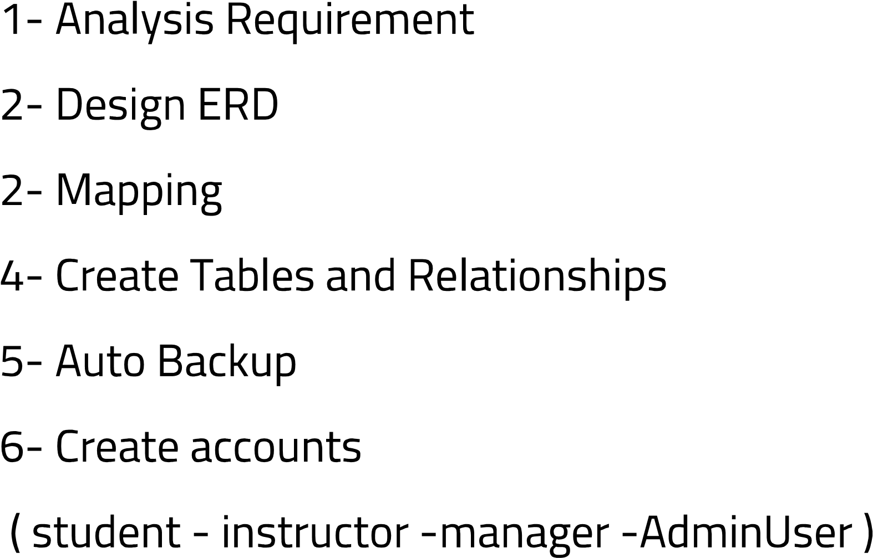

Abdelrahman Mohmed Gomaa

**Stored Procedures :**

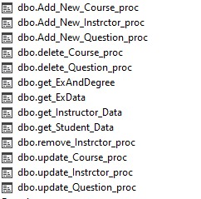

**Function :**

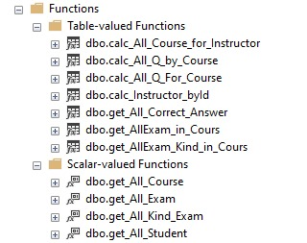

**Trigger :**



Abdelrahman Mohamed Ahmed

**Stored Procedures :**

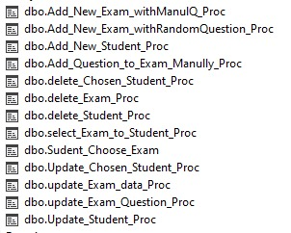

**Index :**

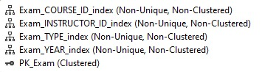

**Views :**

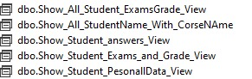

**Trigger :**



Islam Abu elsoud

**Stored Procedures :**

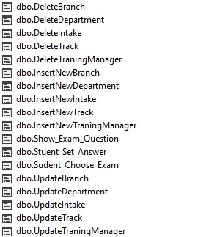

**Views :**

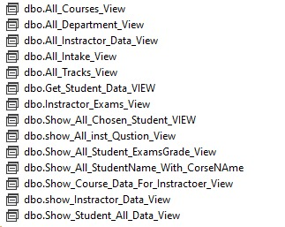

**Trigger :**

